**A Level computer Science**

Component 3

Project Title

Perhaps a Logo / Picture

By: Your Name Here

For: A. Issa

**Stoke on Trent Sixth Form College**

Table of Contents

1.1 Introduction 4

1.2 Problem Identification 5

1.3 Possible Computational Methods 6

1.4 Stakeholders analysis 7

1.4.1 who are Stakeholders ? 7

1.4.2 How they make use of the solution? 7

1.4.3 Why the solution is appropriate to them? 7

1.4.3 Stakeholders’ involvement - Conclusions 7

1.5 Research of solutions for similar problems 8

1.6 Hardware and software requirements 9

1.8 The requirements of the solution 10

1.9 Features of the solution 11

1.10 Success Criteria 12

1.11 Limitations of the solution 13

Chapter One: Analysis of the problem

## 1.1 Introduction

#Write near end

## 1.2 Problem Identification

#Justification in things that you want to change

Inserting Pygame into Tkinter

## 1.3 Possible Computational Methods

Nature of the problem

# Computational approach –

* Abstraction
* Iteration
* Back tracking
* Assertion
* Recursion
* Divide & Conquer
* **These approaches can help you solve millions of problems in coding**

# Problem

If it is solvable then use one of the computational approaches to solve it:

## 1.4 Stakeholders analysis

### 1.4.1 who are Stakeholders ? # Anybody that can affect or be affected by your project are stakeholders

Users are going to use the system

* College/University teachers are the stakeholders

**IMPORTANT**

* Who are the stakeholders?
* - Important details about them e.g., skills, anything related to their role in the project not e.g., if they like certain types of foods
* - How will they use the system e.g., can they use to teach people
* -Why would they want the solution e.g., do they want to educate themselves?

### 1.4.2 How they make use of the solution?

* They can make use of the solution by learning about projectile motion

### 1.4.3 Why the solution is appropriate to them?

* This is because they could use this solution to teach students and test them of their knowledge of projectile motion

### 1.4.3 Stakeholders’ involvement (interview and conclusion)

* Educational purposes

## 1.5 Research of solutions for similar problems

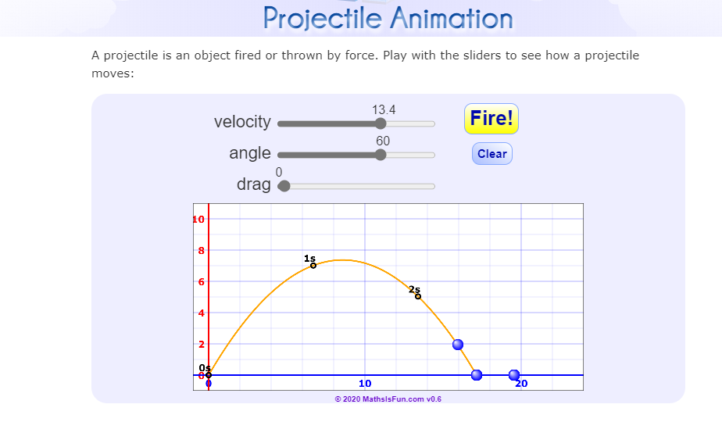

This projectile display is from mathsisfun.com

[Projectile Animation (mathsisfun.com)](https://www.mathsisfun.com/geometry/projectile-animation.html)

*How they work?*

* It is a 2D animation which demonstrates projectile motion of a ball that is fired from the origin of the graph.
* Factors such as velocity, the angle and drag can be altered which can change the motion of the ball.
* It also shows time intervals of each second to show when the ball reaches x height

*Potential features/components/approaches that may be borrowed? why?*

* *Altering the velocity, angle and drag can be borrowed as it allows you to change the motion of the ball which will enhance the project as mathematical calculations can be used.*
* *Also arrows showing the alternations between drag, gravitational potential energy and velocity whilst in motion.*

## 1.6 Hardware and software requirements

Hardware

Refers to the external and internal devices and equipment that enable you to perform major functions such as input, output, storage, communication, processing, and more

Software

Software is a set of instructions, data or programs used to operate computers and execute specific tasks

## 1.8 The requirements of the solution

## 1.9 Features of the solution

## 1.10 Success Criteria

## 1.11 Limitations of the solution